# **Telnet Client**

**How Does Telnet Work?**

The Telnet protocol creates a communication path through a virtual terminal connection. The data distributes in-band with Telnet control information over the transmission control protocol (TCP).

Unlike other TCP/IP protocols, Telnet provides a log-in screen and allows logging in as the remote device’s actual user when establishing a connection on port 23. This type of access grants direct control with all the same privileges as the owner of the credentials.

Telnet comes with a command accessible from the command line in Windows. The telnet command also exists for macOS and Linux operating systems.

**Telnet Windows**

**How to Enable Telnet on Windows**

In Windows systems, Telnet is disabled by default. To check if Telnet is already activated, open your command line, and run telnet:



If the command prompt does not recognize the command, there are two possible ways to enable the Telnet client in Windows.

**Option 1: Enable Telnet using GUI**

1. Open the Programs and Features options in Control Panel:

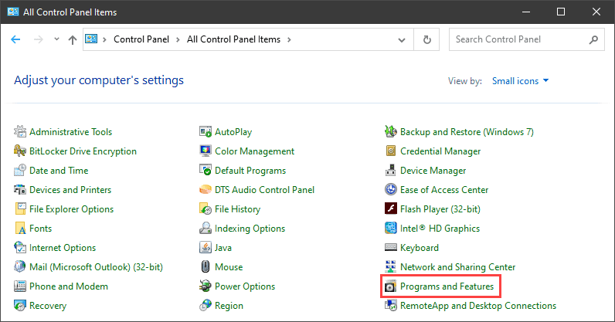

1. Click the Turn Windows features on or off setting:

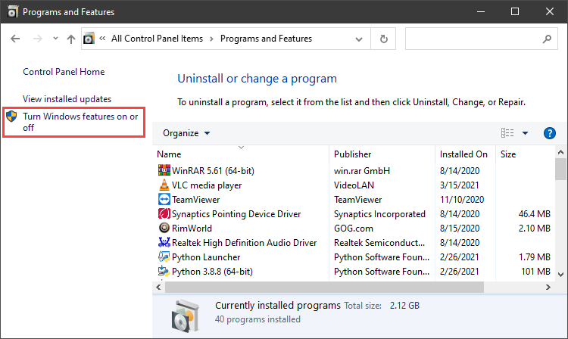

1. Locate the Telnet Client option on the list, select it and click OK to install the feature:

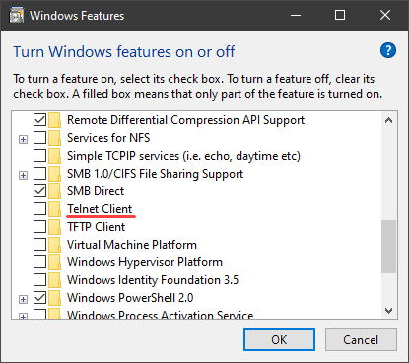

1. When Windows completes the requested change, click Close.
2. Open the command prompt and run telnet to open the Microsoft Telnet Client:

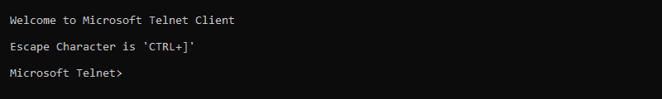

1. Run quit to exit the Telnet client.

**Option 2: Enable Telnet Using Command Prompt**

1. In the command prompt, run:

|  |
| --- |
| pkgmgr /iu:"TelnetClient" |

1. Restart the command prompt and run telnet to open the Microsoft Telnet Client.
2. Run quit to exit the client:

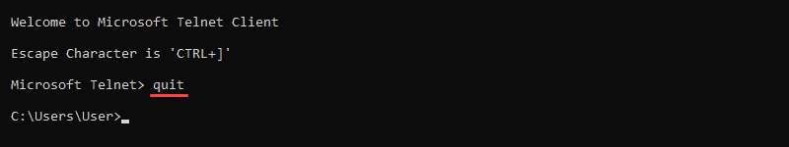

**How to Use Telnet in Windows to Test Open Ports**

1. The Telnet syntax for testing open ports is:

|  |
| --- |
| telnet <address> <port number> |

1. The command accepts both symbolic and numeric addresses. For example:

|  |
| --- |
| telnet towel.blinkenlights.nl 23 |

1. Or alternatively:

|  |
| --- |
| telnet 127.0.0.1 80 |

1. After running the command, one of the following three options happen:  
   -The command throws an error, indicating the port is not available for connection:  
   -The command goes to a blank screen, indicating the port is available.  
   -Running the command on an open port 23 displays the screen of the telnet host, confirming an established Telnet connection:

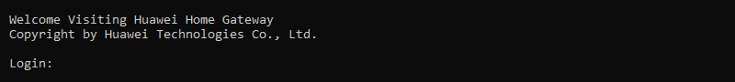

**Telnet Linux**

Telnet command can be installed using YUM in all CentOS and Fedora distributions.

1. Execute the below command to install telnet.

|  |
| --- |
| yum -y install telnet |

1. Verify that the command is installed successfully.

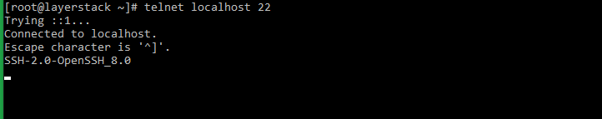

|  |
| --- |
| telnet localhost 22 |